# Power Curve Working Group Open Source Tool Overview

## 

## Contents

1. License
2. Installation
3. Getting Started
4. Benchmark versus Excel Consensus Analysis

## 1 Licence

## The PCWG tool is released under the MIT Software License.

The MIT License (MIT)

Copyright (c) 2014 Peter Stuart

Permission is hereby granted, free of charge, to any person obtaining a copy of this software and associated documentation files (the "Software"), to deal in the Software without restriction, including without limitation the rights to use, copy, modify, merge, publish, distribute, sublicense, and/or sell copies of the Software, and to permit persons to whom the Software is furnished to do so, subject to the following conditions:

The above copyright notice and this permission notice shall be included in all copies or substantial portions of the Software.

THE SOFTWARE IS PROVIDED "AS IS", WITHOUT WARRANTY OF ANY KIND, EXPRESS OR IMPLIED, INCLUDING BUT NOT LIMITED TO THE WARRANTIES OF MERCHANTABILITY, FITNESS FOR A PARTICULAR PURPOSE AND NONINFRINGEMENT. IN NO EVENT SHALL THE AUTHORS OR COPYRIGHT HOLDERS BE LIABLE FOR ANY CLAIM, DAMAGES OR OTHER LIABILITY, WHETHER IN AN ACTION OF CONTRACT, TORT OR OTHERWISE, ARISING FROM, OUT OF OR IN CONNECTION WITH THE SOFTWARE OR THE USE OR OTHER DEALINGS IN THE SOFTWARE.

## 2 Installation

There are two ways to run the PCWG code:

1. Running the standalone .exe
2. Running from the source code

### 2.1 Installing PCWG Executable

To run the PCWG .exe the following steps should be completed:

* Download the latest release from: <https://sourceforge.net/projects/pcwg/files>
* Save the zip file to a local folder

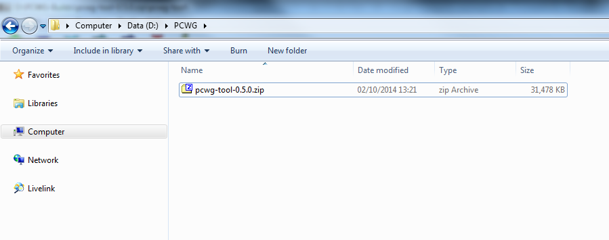

* Extract the contents of the archive pcwg-tool.zip to a local folder e.g. D:\PCWG\PCWG-Tool. Note: you may wish to download 7zip from <http://www.7-zip.org/download.html>

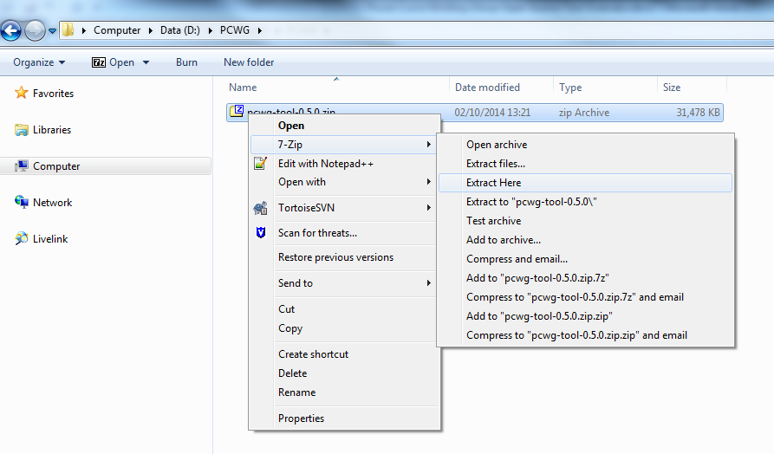

* Double-click on the local executable D:\PCWG\PCWG-Tool \pcwg-tool.exe

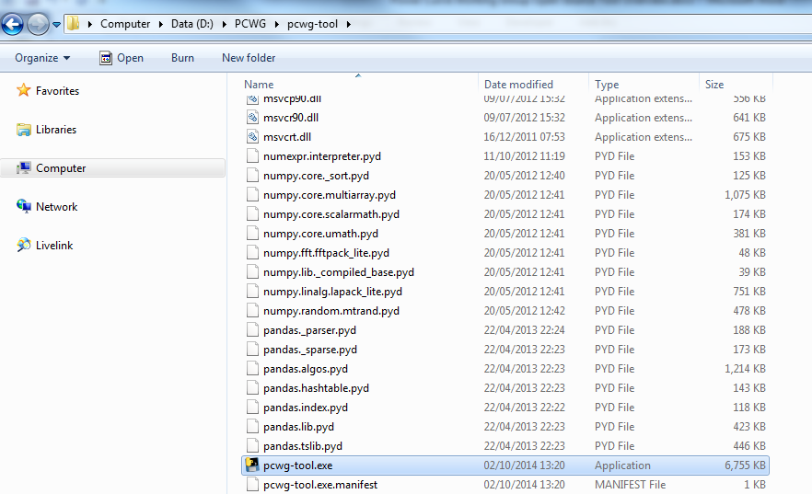

### 2.2 Installing PCWG Source Code

To run the PCWG source code the follow steps should be completed:

* **Install python**:
  + There are several Python distributions available. One particularly convenient distribution is called Anaconda which contains all necessary libraries to run the PCWG code.
  + To download Anaconda Python go to: <http://continuum.io/downloads>
* **Install GitHub Source Control**:
  + Go to <https://windows.github.com>
  + Download the GitHub client for your operating system
* **Clone the PCWG Repository**
  + Go to <https://github.com/peterdougstuart/PCWG>
  + Click on “Clone in Desktop” (see Figure 1)
  + Select the local directory where you wish to store the PCWG code

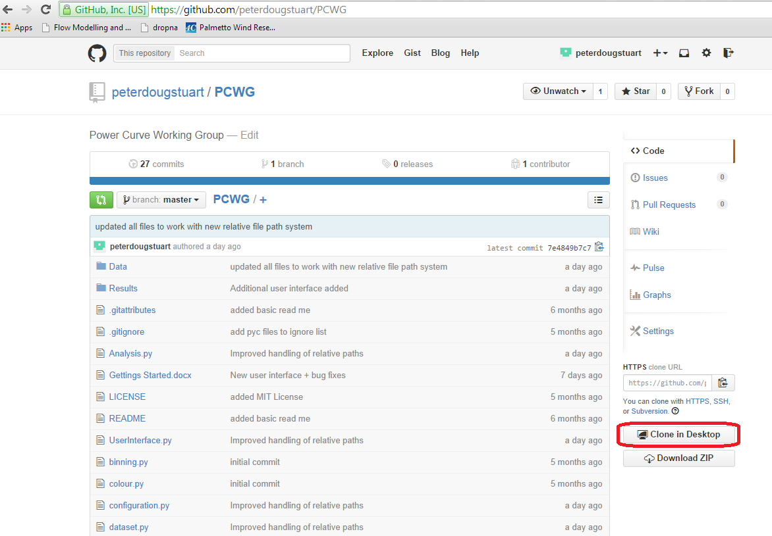

Figure 1. PCWG page on Git Hub

* **Start Integrated Debugging Environment (IDE):**
  + Anaconda comes with a IDE called Spyder which can normally be found in C:\Anaconda\Scripts\spyder.exe.
  + Start Spyder
  + When prompted create a new workspace
  + Goto File > Open, browse to your local PCWG Git folder and open “pcwg-tool.py”
  + Press F5 to run the tool.

## 3 Getting Started

Once the tool is running you should see a screen similar to Figure 2.

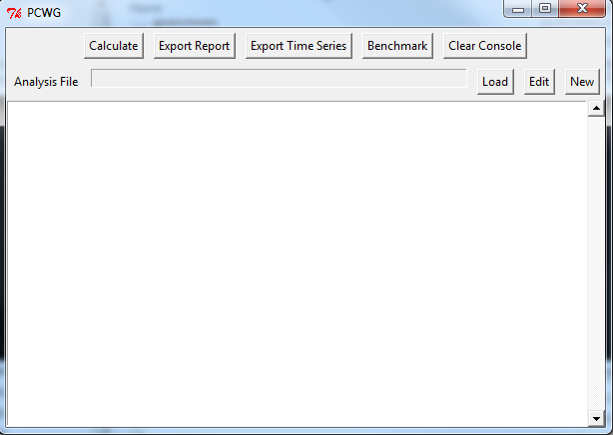

Figure 2. PCWG Tool Home Screen

* To run an example analysis click on the Load button and browse to “Data/Dataset 1 Analysis.xml”. You should see that the file has successfully loaded via the message in the output console (see Figure 3). Note: this example file has been configured to reproduce the results of the PCWG Round Robin Exercises on Dataset 1.

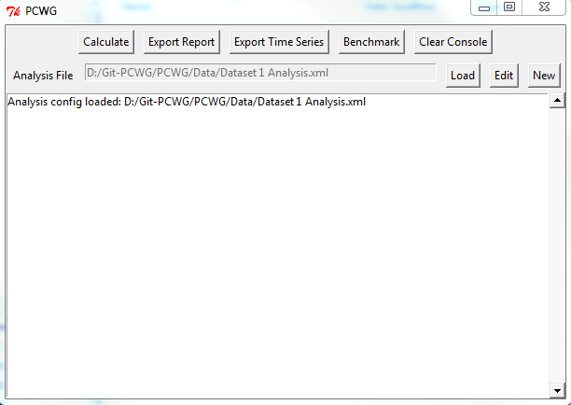

Figure 3. Confirmation of file load in output console

* Once the file has loaded you can inspect the settings by clicking “Edit” (see Figure 3)

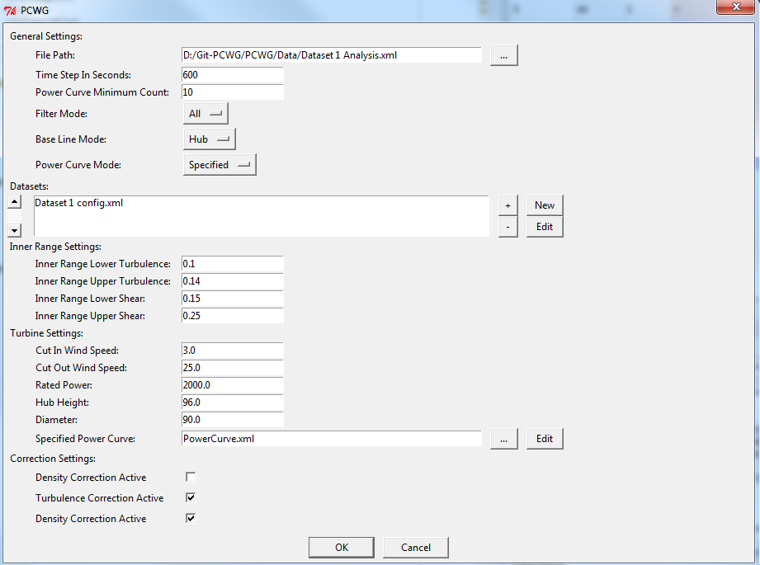

Figure 3. Analysis Settings Dialog

* From the Analysis Settings Dialog click “Cancel” to return to the Home Screen
* To run the calculation click “Calculate”. Note: the calculation currently takes several minutes to complete. As the calculation progresses message will be written to the output console.

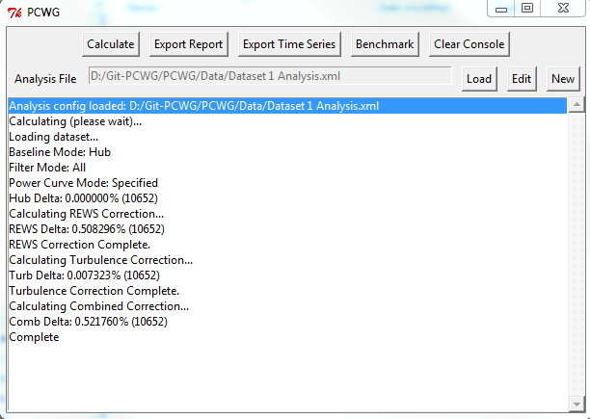

Figure 4. Progress messages displayed in output console

* Once the calculation has completed you can either review the results printed in the output console or export files as follows:
  + Click “Export Report” to export an excel spreadsheet summary.
  + Click “Time Series” to export a “.dat” text file of the calculation results per time step.

## 4 Benchmark versus Excel Consensus Analysis

For convenience the main menu contains a button “Benchmark” which will rerun all PCWG Round Robin Exercises using the tool and compare the results to the Excel consensus analysis.

